Sustainable
Travel Plan

University of Wales Trinity Saint David

Sustainable Travel Plan

1. Introduction
With the launch of Llybyr Newydd (new path) the Wales Transport Strategy 2021, the University seeks to ensure it is supporting the principles as we work toward Net Zero Carbon. The University and TSDSU declared a climate emergency, with travel, alongside utilities are of the greatest areas of carbon emission in any organisation and is also the most challenging to monitor and quantify. These emissions fall under the Scope 3 category and thus the Net Zero ambition linked to these is 2050.

2. Purpose
The Travel and Transport Plan outlines how the University facilitates and promotes convenient, low carbon options for staff, students, and other stakeholders to travel to and between our campuses.
This strategic direction is supported by the following objectives:
- Provide attractive alternatives to single occupancy car journeys.
- Enhance staff and student wellbeing via safe and convenient active travel options.
- Minimise the impact of business travel.
- Accurately quantify the impacts associated with travel and transport on the environment.
- Deliver a safe and affordable parking service.
- Develop an accurate and complete data record of all emissions linked to travel.
Specific targets associated with these objectives are outlined in the section below.

3. Scope
This plan is applicable to all students, staff members and all other university stakeholders. The plan is applicable to all aspects of travel whilst undertaking university business and includes commuting travel between residence and workplace/place of study. It also applies to all aspects of travel for university business including road, rail, air and boat travel.

4. Background

Operational environment
University of Wales Trinity Saint David (UWTSD) has campuses across England and Wales.
This scope includes a mixture of established campuses and buildings that are new to the University. It is important to the University to balance the existing demands on local travel infrastructure with the additional pressures applied by the growing University, while minimising any negative impacts on the environment.
As economic activity increases across West Wales, the pressure on our travel and transport network also increases. This is reflected in more stringent planning requirements associated with estates development and additional scrutiny from local residents and stakeholders. The University wishes to demonstrate a responsible approach to growth by proactively addressing these demands.
External factors such and the Swansea City Deal and the focus on Carmarthen becoming a digital media hub provide the opportunity for UWTSD to link strategic advancements into the wider regional economy. Advances in technology, including proliferation of electric vehicles and advanced traffic management and phasing technology provide the tools to achieve these aims.
This Travel and Transport Plan is a dynamic document that aims to link travel networks across West Wales to provide viable solutions to staff, students and visitors. A combined plan has been produced to encourage sustainable travel options across campus and avoid the risk of operational silos.

Travel management structure
The day-to-day management of travel and transport activities is undertaken by the Sustainability Delivery Team within the Estates and Facilities Directorate. This currently falls within the remit of the Executive Head of Operational Estates and Facilities.
Wider staff and student engagement in the area is facilitated via the Sustainability Development Group, who meet on a quarterly basis. This group has representation from every institute and professional service across the University, TSDSU and the FE colleges.
Parking Management Services are be managed by an external supplier.

Environmental factors
University travel and transport, including commuting, business travel and third-party related activities have been identified as a significant environmental aspect. This has been highlighted due to the contribution the aspect has to climate change and local air pollution. In addition to environmental concerns, poor travel management can have adverse effects on wellbeing and the safety of individuals.

5. Delivering objectives
UWTSD publishes a Travel Plan that details operational measures in place to deliver Travel and Transport Objectives, including:

Provide attractive alternatives to single occupancy car journeys.
Single occupancy car journeys place significant pressure throughout the transport network, from the national road network to university car parks. Reducing these journeys helps minimise our impact on the environment and improve overall wellbeing. These trips include staff and students coming to campus as well as business mileage. A majority of people use the car out of convenience or habit. The only way to move people away from this is to make alternatives to car use seem more attractive and accessible to users.
There are a range of opportunities to achieve this:
  - Introduce car park management which can include permit systems, charging and restricting access.
  - Promote car sharing and give priority parking to those who share their car with others.
  - Offer staff who don’t come by car equivalent benefits or rewards to that of a car parking space.
  - Provision of benefits for staff who cycle and walk between campuses.
  - Ensure that active and public transport is promoted and accessible.
  - Work to remove the idea that car parking is a ‘right’ and promote the idea that spaces are only for those who need them.
  - Get company pool cars so that staff who do not drive to work have access to a vehicle.
  - Subsidise EV charging to encourage use of Electric Vehicles.
  - Offer Salary Sacrifice Schemes on Cycling and Electric Vehicles.
  - Develop a travel app which staff and students can use to identify public transport and car sharing opportunities.

Enhance staff and student wellbeing via safe and convenient active travel options.
The best solution for travelling to and from campus for the environment and individual wellbeing is active travel. This includes travel by foot or by bicycle and is a viable option for many. Based on feedback from the last UWTSD travel survey, the main reasons people avoid active transport are:
- Concern about personal safety, either associated with cycling or walking alone.
- The need to bring heavy or bulky equipment to site.
- Concerns about onward travel from campus, for instance intercampus travel at short notice.
- Secure storage for cycling.
- Access to showers after a long cycle or walk.
It is recognised that it will never be possible to solve these concerns for all users. The annual travel plan seeks to provide attractive solutions to as many users as possible.
We are establishing a number of surveys to produce an accurate commuting travel baseline over the 2022/23 academic year. With a better understanding of how our staff and student commute the university can establish a program to educate and minimize commuting emissions. This baseline data will allow us to produce valid SMART targets to produce measurable reductions over the 2023/24 academic year.

Minimise the impact of business travel.
Our business travel emissions accounted for 2% of our overall emissions when our baseline was set in the 2016/17 academic year. This highlighted the importance of reviewing travel and implementing reduction strategies as defined within the Sustainable travel action plan. The University’s recommended mode of travel is by rail/bus or pool car. Where this is not possible, employees may use their own cars for business journeys. For journeys over 160 miles employees should consider the use of hire cars - for return journeys over 160 miles (or which average more than 160 miles per day where periods longer than a single day are involved), this option should normally be used whenever practicable in preference to the use of a private car. Our Sustainable Travel Action Plan details the current targeted approach to reductions in business travel emissions, and we have set the below overreaching target for reductions. With the development of hybrid working systems the university has given priority to digital collaboration and online meetings as standard greatly reducing the frequency of inter campus business travel requirements.
The business travel baseline was set based on the 2016/17: 667 tCO²e emissions rate as this was the year that showed consistent and accurate travel data recording. In line with the hybrid working approach, we have set a 15% target for reduction in business travel emissions by 2025 in terms of FTE staff from the baseline.
The Wales Transport Strategy 2021 refers to the Sustainable Transport Hierarchy and the University commits to promoting this as a thought-based approach to decisions linked to travel.
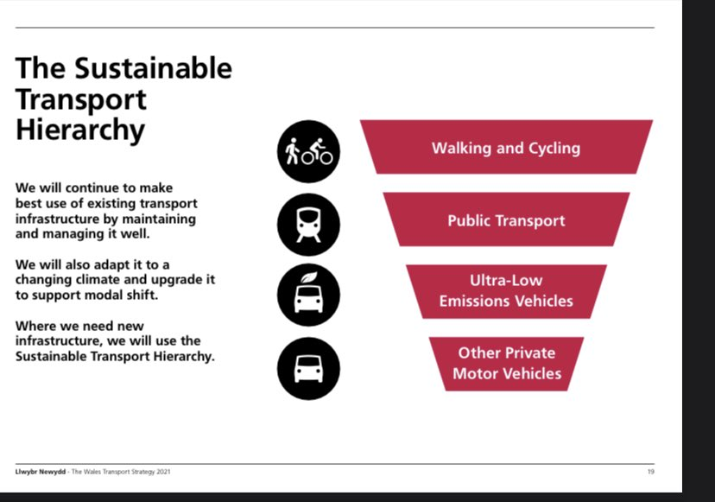
Staff and students are encouraged to follow this detailed hierarchy when deciding on whether to attend a meeting or conference off site:
- Is this meeting necessary?
- Can all meetings that are face to face be scheduled on the same day?
- If travelling for only 1 meeting, would a teams call be the more environmentally sensible option?
- Can I walk, cycle or take the bus for local meetings?
- Can I take the train?
- Is it possible to car share?

Deliver a safe and affordable parking service.
UWTSD recognise that a degree of parking will always be required on our campuses. This should be provided on an equitable basis and not take funding from other elements of university activity. Parking management should be funded by the users of the parking system wherever possible.
Action plan as annexe
Comms plan

6. Monitoring
Travel data is monitored by the Sustainability team within the operational estates department. Travel data is consolidated annually for presentation HESA to as part of the Estates Management Record. Development of an annual survey of staff and student commute will ensure accurate data record of commuting emissions going forward. Annual review of data allows for targeted planning for future reductions in line with the action plan attached at Appendix A

To continue to inform decision making and communications around travel and transport, UWTSD will continue to collect information and aim to improve the quality of that data in the following areas:
- Grey and owned fleet
- Air travel
- Rail travel
- Bus and coach travel
- Staff and student commuting
- Active travel
- Car parking
Careful analysis and dissemination of this information will be used to facilitate the other objectives laid out in this strategy. This data is reportable to HESA and forms part of the reporting into the EMS (environmental management system)

7. Summary
Targeted reductions across all aspects of travel within the university will ensure we are achieving our emission reductions targets in line with Welsh governments Scope 1 & 2 net zero by 2030 guidance. Ensuring we utilise sustainable travel and commuting practices will ensure the sustainability of the university and the planet for future generations and achieve the scope 3 net zero 2045 target. Maintaining an accessible campus for all users ensures travel is considered as part of planning for the future within the university.

8. Links to other policies / procedures
Net Zero Interim Plan

9. Document version control

Version No: | Reason for change: | Author: | Date of change:
1.00 |  | KW | 30/06/22
2.00 | Scope 3 target date amended | KLW | 11/04/24

Applicable to: HE

Author(s):

Kelly Williams Job Title: Exec. Head of Operational Estates and Facilities

Date effective from: 30/06/2022

Policy review date: 30/06/2025

For publication: on UWTSD (University of Wales Trinity Saint David) website.

Appendix A: Sustainable Travel Action Plan
This action plan lists the ongoing and planned actions to be undertaken over the 2022/23 - 2024/25 academic years. These actions will allow baseline data to be established and measure our progress toward the reduction target within the sustainable travel plan. The action plan will be reviewed annually and published within the sustainability section of the university webpage for public access.

Action | Location | Target Date | Progress
Review car share commute process | All | August 2023 | Process Reviewed. Investigating a Travel App
Develop Car share priority parking bays. | Swansea | November 2024
Review cycle to work scheme | All | February 2023 | Reviewed Feb 2023  To Continue and review in detail
Review foot traffic routes for commute | All | September 2024
Review cycle routes for commute | All | September 2024
Review fossil fuel vehicle fleet for EV viability | All | Annually February | Reviewed, EV fleet deemed viable
ANPR Permit parking system | All | September 2022 | Parking Eye
Staff and student commute survey | All | February 2023  October 2023 | Completed  Repeat m6
Education campaign around virtual collaboration | All | March 2023 | Complete
Departmental travel emissions scorecard | All | July 2025
Review rental partners, with priority to EVs | All | August 2023 | Complete
Voluntary travel carbon offset scheme | All | September 2025
Develop hybrid working emissions baseline. | All | October 2024
Review cycle storage infrastructure | All | November 2022 | Reviewed. More required. Scoping undertaken
Review potential for EV priority parking | Swansea | December 2023 | IQ Complete
Transition fleet to EVs | All | Planned implementation October 2022 | Planning Complete  80% of fleet identified for conversion to EV  Complete
Viability of cycle docking stations at strategic campus locations | Swansea | December 2024
Review viability of electric pool cycles | Swansea | December 2023 | In progress
Cycle mileage allowance | All | Feasibility August 2023 | complete
Education campaign on sustainable commuting | All | Cycle to Workday | In progress
Join Swansea Sustainable Travel Charter | Swansea | July 2022 | complete

